PRESERVE.
SET DECIMAL DOT.

GET DATA /TYPE=TXT
/FILE="D:\Life Expectancy Data.csv"
/ENCODING='UTF8'
/DELIMITERS=","
/QUALIFIER='"'
/ARRANGEMENT=DELIMITED
/FIRSTCASE=2
/DATATYPEMIN PERCENTAGE=95.0
/VARIABLES=
Country AUTO
Year AUTO
Status AUTO
Lifeexpectancy AUTO
AdultMortality AUTO
infantdeaths AUTO
Alcohol AUTO
percentageexpenditure AUTO
HepatitisB AUTO
Measles AUTO
BMI AUTO
underfivedeaths AUTO
Polio AUTO
Totalexpenditure AUTO
Diphtheria AUTO
HIVAIDS AUTO
GDP AUTO
Population AUTO
thinness119years AUTO
thinness59years AUTO
Incomecompositionofresources AUTO
Schooling AUTO
/MAP.
RESTORE.
CACHE.
EXECUTE.

Data written to the working file.
22 variables and 2938 cases written.
Variable: Country Type: String Format : A52
Variable: Year Type: Number Format : F4
Variable: Status Type: String Format : A10
Variable: Lifeexpectancy Type: Number Format : F4.1 One or more values were set to system-missing.
Variable: AdultMortality Type: Number Format : F3 One or more values were set to system-missing.
Variable: infantdeaths Type: Number Format : F4
Variable: Alcohol Type: Number Format : F5.2 One or more values were set to system-missing.
Variable: percentageexpenditure Type: Number Format : F13.9
Variable: HepatitisB Type: Number Format : F2 One or more values were set to system-missing.
Variable: Measles Type: Number Format : F6
Variable: BMI Type: Number Format : F4.1 One or more values were set to system-missing.
Variable: underfivedeaths Type: Number Format : F4
Variable: Polio Type: Number Format : F2 One or more values were set to system-missing.
Variable: Totalexpenditure Type: Number Format : F5.2 One or more values were set to system-missing.
Variable: Diphtheria Type: Number Format : F2 One or more values were set to system-missing.
Variable: HIVAIDS Type: Number Format : F4.1
Variable: GDP Type: Number Format : F12.7 One or more values were set to system-missing.
Variable: Population Type: Number Format : F11.2 One or more values were set to system-missing.
Variable: thinness119years Type: Number Format : F4.1 One or more values were set to system-missing.
Variable: thinness59years Type: Number Format : F4.1 One or more values were set to system-missing.
Variable: Incomecompositionofresources Type: Number Format : F5.3 One or more values were set to system-missing.
Variable: Schooling Type: Number Format : F4.1 One or more values were set to system-missing.

Substitute the following to build syntax for these data.
/VARIABLES=
Country A52
Year F4
Status A10
Lifeexpectancy F4.1
AdultMortality F3
infantdeaths F4
Alcohol F5.2
percentageexpenditure F13.9
HepatitisB F2
Measles F6
BMI F4.1
underfivedeaths F4
Polio F2
Totalexpenditure F5.2
Diphtheria F2
HIVAIDS F4.1
GDP F12.7
Population F11.2
thinness119years F4.1
thinness59years F4.1
Incomecompositionofresources F5.3
Schooling F4.1

DATASET NAME DataSet1 WINDOW=FRONT.

FILTER OFF.
USE ALL.
SELECT IF (NOT(SYSMIS(Year) OR SYSMIS(Lifeexpectancy) OR SYSMIS(AdultMortality) OR
SYSMIS(infantdeaths) OR SYSMIS(Alcohol) OR SYSMIS(percentageexpenditure) OR SYSMIS(HepatitisB)
OR SYSMIS(Measles) OR SYSMIS(BMI) OR SYSMIS(underfivedeaths) OR SYSMIS(Polio) OR
SYSMIS(Totalexpenditure) OR SYSMIS(Diphtheria) OR SYSMIS(HIVAIDS) OR SYSMIS(GDP) OR
SYSMIS(Population) OR SYSMIS(thinness119years) OR SYSMIS(thinness59years) OR
SYSMIS(Incomecompositionofresources) OR SYSMIS(Schooling) )).
EXECUTE.
* Visual Binning.
*GDP.
RECODE GDP (MISSING=COPY) (LO THRU 1.65=1) (LO THRU 11918.759=2) (LO THRU 23835.8680000000=3) (LO
THRU 35752.9770000000=4) (LO THRU 47670.086=5) (LO THRU 59587.195=6) (LO THRU 71504.304=7) (LO THRU
83421.413=8) (LO THRU 95338.522=9) (LO THRU 107255.631=10) (LO THRU HI=11) (ELSE=SYSMIS) INTO
GDPGROUPS.
VARIABLE LABELS GDPGROUPS 'GDP (Binned)'.
FORMATS GDPGROUPS (F5.0).
VALUE LABELS GDPGROUPS 1 '<= 1.6500000' 2 '1.6500001 - 11918.7590000' 3 '11918.7590001 - '+
'23835.8680000' 4 '23835.8680001 - 35752.9770000' 5 '35752.9770001 - 47670.0860000' 6
'47670.0860001 - 59587.1950000' 7 '59587.1950001 - 71504.3040000' 8 '71504.3040001 - 83421.4130000'
9 '83421.4130001 - 95338.5220000' 10 '95338.5220001 - 107255.6310000' 11 '107255.6310001+'.
VARIABLE LEVEL GDPGROUPS (ORDINAL).
EXECUTE.
GLM Lifeexpectancy AdultMortality BY Status GDPGROUPS
/METHOD=SSTYPE(3)
/INTERCEPT=INCLUDE
/CRITERIA=ALPHA(.05)
/DESIGN= Status GDPGROUPS Status*GDPGROUPS.

General Linear Model

Notes
Output Created |  | 11-SEP-2024 20:39:54
Comments
Input | Active Dataset | DataSet1
Input | Filter | <none>
Input | Weight | <none>
Input | Split File | <none>
Input | N of Rows in Working Data File | 1649
Missing Value Handling | Definition of Missing | User-defined missing values are treated as missing.
Missing Value Handling | Cases Used | Statistics are based on all cases with valid data for all variables in the model.
Syntax |  | GLM Lifeexpectancy AdultMortality BY Status GDPGROUPS  /METHOD=SSTYPE(3)  /INTERCEPT=INCLUDE  /CRITERIA=ALPHA(.05)  /DESIGN= Status GDPGROUPS Status*GDPGROUPS.
Resources | Processor Time | 00:00:00.06
Resources | Elapsed Time | 00:00:00.09

[DataSet1]

Between-Subjects Factors
 |  | Value Label | N
Status | 1 | Developing | 1407
Status | 2 | developed | 242
GDP (Binned) | 2 | 1.6500001 - 11918.7590000 | 1452
GDP (Binned) | 3 | 11918.7590001 - 23835.8680000 | 99
GDP (Binned) | 4 | 23835.8680001 - 35752.9770000 | 38
GDP (Binned) | 5 | 35752.9770001 - 47670.0860000 | 30
GDP (Binned) | 6 | 47670.0860001 - 59587.1950000 | 18
GDP (Binned) | 7 | 59587.1950001 - 71504.3040000 | 6
GDP (Binned) | 8 | 71504.3040001 - 83421.4130000 | 1
GDP (Binned) | 9 | 83421.4130001 - 95338.5220000 | 1
GDP (Binned) | 11 | 107255.6310001+ | 4

Multivariate Testsª
Effect |  | Value | F | Hypothesis df | Error df
Intercept | Pillai's Trace | .849 | 4602.467^{b} | 2.000 | 1634.000
Intercept | Wilks' Lambda | .151 | 4602.467^{b} | 2.000 | 1634.000
Intercept | Hotelling's Trace | 5.633 | 4602.467^{b} | 2.000 | 1634.000
Intercept | Roy's Largest Root | 5.633 | 4602.467^{b} | 2.000 | 1634.000
Status | Pillai's Trace | .001 | 1.174^{b} | 2.000 | 1634.000
Status | Wilks' Lambda | .999 | 1.174^{b} | 2.000 | 1634.000
Status | Hotelling's Trace | .001 | 1.174^{b} | 2.000 | 1634.000
Status | Roy's Largest Root | .001 | 1.174^{b} | 2.000 | 1634.000
GDPGROUPS | Pillai's Trace | .069 | 7.324 | 16.000 | 3270.000
GDPGROUPS | Wilks' Lambda | .931 | 7.454^{b} | 16.000 | 3268.000
GDPGROUPS | Hotelling's Trace | .074 | 7.584 | 16.000 | 3266.000
GDPGROUPS | Roy's Largest Root | .074 | 15.150^{c} | 8.000 | 1635.000
Status * GDPGROUPS | Pillai's Trace | .036 | 7.416 | 8.000 | 3270.000
Status * GDPGROUPS | Wilks' Lambda | .964 | 7.477^{b} | 8.000 | 3268.000
Status * GDPGROUPS | Hotelling's Trace | .037 | 7.537 | 8.000 | 3266.000
Status * GDPGROUPS | Roy's Largest Root | .036 | 14.907^{c} | 4.000 | 1635.000

Multivariate Testsª
Effect |  | Sig.
Intercept | Pillai's Trace | .000
Intercept | Wilks' Lambda | .000
Intercept | Hotelling's Trace | .000
Intercept | Roy's Largest Root | .000
Status | Pillai's Trace | .309
Status | Wilks' Lambda | .309
Status | Hotelling's Trace | .309
Status | Roy's Largest Root | .309
GDPGROUPS | Pillai's Trace | .000
GDPGROUPS | Wilks' Lambda | .000
GDPGROUPS | Hotelling's Trace | .000
GDPGROUPS | Roy's Largest Root | .000
Status * GDPGROUPS | Pillai's Trace | .000
Status * GDPGROUPS | Wilks' Lambda | .000
Status * GDPGROUPS | Hotelling's Trace | .000
Status * GDPGROUPS | Roy's Largest Root | .000

a. Design: Intercept + Status + GDPGROUPS + Status * GDPGROUPS
b. Exact statistic
c. The statistic is an upper bound on F that yields a lower bound on the significance level.

Tests of Between-Subjects Effects
Source | Dependent Variable | Type III Sum of Squares | df | Mean Square | F
Corrected Model | Lifeexpectancy | 35587.767ª | 13 | 2737.521 | 48.681
Corrected Model | AdultMortality | 2638846.850^{b} | 13 | 202988.219 | 14.281
Intercept | Lifeexpectancy | 264079.808 | 1 | 264079.808 | 4696.141
Intercept | AdultMortality | 312005.850 | 1 | 312005.850 | 21.951
Status | Lifeexpectancy | 124.440 | 1 | 124.440 | 2.213
Status | AdultMortality | 22754.818 | 1 | 22754.818 | 1.601
GDPGROUPS | Lifeexpectancy | 6573.037 | 8 | 821.630 | 14.611
GDPGROUPS | AdultMortality | 453497.298 | 8 | 56687.162 | 3.988
Status * GDPGROUPS | Lifeexpectancy | 3046.657 | 4 | 761.664 | 13.545
Status * GDPGROUPS | AdultMortality | 148245.820 | 4 | 37061.455 | 2.607
Error | Lifeexpectancy | 91941.544 | 1635 | 56.233
Error | AdultMortality | 23239203.725 | 1635 | 14213.580
Total | Lifeexpectancy | 8047362.010 | 1649
Total | AdultMortality | 72538783.000 | 1649
Corrected Total | Lifeexpectancy | 127529.311 | 1648
Corrected Total | AdultMortality | 25878050.575 | 1648

Tests of Between-Subjects Effects
Source | Dependent Variable | Sig.
Corrected Model | Lifeexpectancy | .000
Corrected Model | AdultMortality | .000
Intercept | Lifeexpectancy | .000
Intercept | AdultMortality | .000
Status | Lifeexpectancy | .137
Status | AdultMortality | .206
GDPGROUPS | Lifeexpectancy | .000
GDPGROUPS | AdultMortality | .000
Status * GDPGROUPS | Lifeexpectancy | .000
Status * GDPGROUPS | AdultMortality | .034
Error | Lifeexpectancy
Error | AdultMortality
Total | Lifeexpectancy
Total | AdultMortality
Corrected Total | Lifeexpectancy
Corrected Total | AdultMortality

a. R Squared = .279 (Adjusted R Squared = .273)
b. R Squared = .102 (Adjusted R Squared = .095)

GLM Lifeexpectancy AdultMortality BY Status GDPGROUPS
/METHOD=SSTYPE(3)
/INTERCEPT=INCLUDE
/SAVE=PRED ZRESID
/PLOT=PROFILE(Status GDPGROUPS) TYPE=BAR ERRORBAR=NO MEANREFERENCE=NO
/EMMEANS=TABLES(OVERALL)
/EMMEANS=TABLES(Status)
/EMMEANS=TABLES(GDPGROUPS)
/EMMEANS=TABLES(Status*GDPGROUPS)
/CRITERIA=ALPHA(.05)
/DESIGN= Status GDPGROUPS Status*GDPGROUPS.

General Linear Model

Notes
Output Created |  | 11-SEP-2024 20:43:42
Comments
Input | Active Dataset | DataSet1
Input | Filter | <none>
Input | Weight | <none>
Input | Split File | <none>
Input | N of Rows in Working Data File | 1649
Missing Value Handling | Definition of Missing | User-defined missing values are treated as missing.
Missing Value Handling | Cases Used | Statistics are based on all cases with valid data for all variables in the model.
Syntax |  | GLM Lifeexpectancy AdultMortality BY Status GDPGROUPS  /METHOD=SSTYPE(3)  /INTERCEPT=INCLUDE  /SAVE=PRED ZRESID  /PLOT=PROFILE(Status GDPGROUPS) TYPE=BAR ERRORBAR=NO MEANREFERENCE=NO  /EMMEANS=TABLES(OVERALL)  /EMMEANS=TABLES(Status)  /EMMEANS=TABLES(GDPGROUPS)  /EMMEANS=TABLES(Status*GDPGROUPS)  /CRITERIA=ALPHA(.05)  /DESIGN= Status GDPGROUPS Status*GDPGROUPS.
Resources | Processor Time | 00:00:09.34
Resources | Elapsed Time | 00:00:06.88
Variables Created or Modified | PRE_1 | Predicted Value for Lifeexpectancy
Variables Created or Modified | PRE_2 | Predicted Value for AdultMortality
Variables Created or Modified | ZRE_1 | Standardized Residual for Lifeexpectancy
Variables Created or Modified | ZRE_2 | Standardized Residual for AdultMortality

Between-Subjects Factors
 |  | Value Label | N
Status | 1 | Developing | 1407
Status | 2 | developed | 242
GDP (Binned) | 2 | 1.6500001 - 11918.7590000 | 1452
GDP (Binned) | 3 | 11918.7590001 - 23835.8680000 | 99
GDP (Binned) | 4 | 23835.8680001 - 35752.9770000 | 38
GDP (Binned) | 5 | 35752.9770001 - 47670.0860000 | 30
GDP (Binned) | 6 | 47670.0860001 - 59587.1950000 | 18
GDP (Binned) | 7 | 59587.1950001 - 71504.3040000 | 6
GDP (Binned) | 8 | 71504.3040001 - 83421.4130000 | 1
GDP (Binned) | 9 | 83421.4130001 - 95338.5220000 | 1
GDP (Binned) | 11 | 107255.6310001+ | 4

Multivariate Testsª
Effect |  | Value | F | Hypothesis df | Error df
Intercept | Pillai's Trace | .849 | 4602.467^{b} | 2.000 | 1634.000
Intercept | Wilks' Lambda | .151 | 4602.467^{b} | 2.000 | 1634.000
Intercept | Hotelling's Trace | 5.633 | 4602.467^{b} | 2.000 | 1634.000
Intercept | Roy's Largest Root | 5.633 | 4602.467^{b} | 2.000 | 1634.000
Status | Pillai's Trace | .001 | 1.174^{b} | 2.000 | 1634.000
Status | Wilks' Lambda | .999 | 1.174^{b} | 2.000 | 1634.000
Status | Hotelling's Trace | .001 | 1.174^{b} | 2.000 | 1634.000
Status | Roy's Largest Root | .001 | 1.174^{b} | 2.000 | 1634.000
GDPGROUPS | Pillai's Trace | .069 | 7.324 | 16.000 | 3270.000
GDPGROUPS | Wilks' Lambda | .931 | 7.454^{b} | 16.000 | 3268.000
GDPGROUPS | Hotelling's Trace | .074 | 7.584 | 16.000 | 3266.000
GDPGROUPS | Roy's Largest Root | .074 | 15.150^{c} | 8.000 | 1635.000
Status * GDPGROUPS | Pillai's Trace | .036 | 7.416 | 8.000 | 3270.000
Status * GDPGROUPS | Wilks' Lambda | .964 | 7.477^{b} | 8.000 | 3268.000
Status * GDPGROUPS | Hotelling's Trace | .037 | 7.537 | 8.000 | 3266.000
Status * GDPGROUPS | Roy's Largest Root | .036 | 14.907^{c} | 4.000 | 1635.000

Multivariate Testsª
Effect |  | Sig.
Intercept | Pillai's Trace | .000
Intercept | Wilks' Lambda | .000
Intercept | Hotelling's Trace | .000
Intercept | Roy's Largest Root | .000
Status | Pillai's Trace | .309
Status | Wilks' Lambda | .309
Status | Hotelling's Trace | .309
Status | Roy's Largest Root | .309
GDPGROUPS | Pillai's Trace | .000
GDPGROUPS | Wilks' Lambda | .000
GDPGROUPS | Hotelling's Trace | .000
GDPGROUPS | Roy's Largest Root | .000
Status * GDPGROUPS | Pillai's Trace | .000
Status * GDPGROUPS | Wilks' Lambda | .000
Status * GDPGROUPS | Hotelling's Trace | .000
Status * GDPGROUPS | Roy's Largest Root | .000

a. Design: Intercept + Status + GDPGROUPS + Status * GDPGROUPS
b. Exact statistic
c. The statistic is an upper bound on F that yields a lower bound on the significance level.

Tests of Between-Subjects Effects
Source | Dependent Variable | Type III Sum of Squares | df | Mean Square | F
Corrected Model | Lifeexpectancy | 35587.767ª | 13 | 2737.521 | 48.681
Corrected Model | AdultMortality | 2638846.850^{b} | 13 | 202988.219 | 14.281
Intercept | Lifeexpectancy | 264079.808 | 1 | 264079.808 | 4696.141
Intercept | AdultMortality | 312005.850 | 1 | 312005.850 | 21.951
Status | Lifeexpectancy | 124.440 | 1 | 124.440 | 2.213
Status | AdultMortality | 22754.818 | 1 | 22754.818 | 1.601
GDPGROUPS | Lifeexpectancy | 6573.037 | 8 | 821.630 | 14.611
GDPGROUPS | AdultMortality | 453497.298 | 8 | 56687.162 | 3.988
Status * GDPGROUPS | Lifeexpectancy | 3046.657 | 4 | 761.664 | 13.545
Status * GDPGROUPS | AdultMortality | 148245.820 | 4 | 37061.455 | 2.607
Error | Lifeexpectancy | 91941.544 | 1635 | 56.233
Error | AdultMortality | 23239203.725 | 1635 | 14213.580
Total | Lifeexpectancy | 8047362.010 | 1649
Total | AdultMortality | 72538783.000 | 1649
Corrected Total | Lifeexpectancy | 127529.311 | 1648
Corrected Total | AdultMortality | 25878050.575 | 1648

Tests of Between-Subjects Effects
Source | Dependent Variable | Sig.
Corrected Model | Lifeexpectancy | .000
Corrected Model | AdultMortality | .000
Intercept | Lifeexpectancy | .000
Intercept | AdultMortality | .000
Status | Lifeexpectancy | .137
Status | AdultMortality | .206
GDPGROUPS | Lifeexpectancy | .000
GDPGROUPS | AdultMortality | .000
Status * GDPGROUPS | Lifeexpectancy | .000
Status * GDPGROUPS | AdultMortality | .034
Error | Lifeexpectancy
Error | AdultMortality
Total | Lifeexpectancy
Total | AdultMortality
Corrected Total | Lifeexpectancy
Corrected Total | AdultMortality

a. R Squared = .279 (Adjusted R Squared = .273)
b. R Squared = .102 (Adjusted R Squared = .095)

Estimated Marginal Means

1. Grand Mean
Dependent Variable | Mean | Std. Error | 95% Confidence Interval
Dependent Variable | Mean | Std. Error | Lower Bound | Upper Bound
Lifeexpectancy | 79.424ª | .971 | 77.520 | 81.328
AdultMortality | 82.977ª | 15.435 | 52.703 | 113.251

a. Based on modified population marginal mean.

2. Status
Dependent Variable | Status | Mean | Std. Error | 95% Confidence Interval
 |  |  |  | Lower Bound | Upper Bound
Lifeexpectancy | Developing | 77.903ª | 1.240 | 75.472 | 80.334
Lifeexpectancy | developed | 80.269 | 1.344 | 77.633 | 82.905
AdultMortality | Developing | 101.517ª | 19.707 | 62.863 | 140.171
AdultMortality | developed | 72.677 | 21.368 | 30.765 | 114.589

a. Based on modified population marginal mean.

3. GDP (Binned)
Dependent Variable | GDP (Binned) | Mean | Std. Error | 95% Confidence Interval
 |  |  |  | Lower Bound | Upper Bound
Lifeexpectancy | 1.6500001 - 11918.7590000 | 72.261 | .355 | 71.566 | 72.957
Lifeexpectancy | 11918.7590001 - 23835.8680000 | 76.948 | .754 | 75.470 | 78.427
Lifeexpectancy | 23835.8680001 - 35752.9770000 | 81.013 | 1.261 | 78.540 | 83.486
Lifeexpectancy | 35752.9770001 - 47670.0860000 | 82.366 | 1.421 | 79.580 | 85.153
Lifeexpectancy | 47670.0860001 - 59587.1950000 | 82.125 | 2.812 | 76.609 | 87.641
Lifeexpectancy | 59587.1950001 - 71504.3040000 | 81.633ª | 3.061 | 75.629 | 87.638
Lifeexpectancy | 71504.3040001 - 83421.4130000 | 78.700ª | 7.499 | 63.992 | 93.408
Lifeexpectancy | 83421.4130001 - 95338.5220000 | 79.400ª | 7.499 | 64.692 | 94.108
Lifeexpectancy | 107255.6310001+ | 82.775ª | 3.749 | 75.421 | 90.129
AdultMortality | 1.6500001 - 11918.7590000 | 142.276 | 5.639 | 131.216 | 153.337
AdultMortality | 11918.7590001 - 23835.8680000 | 103.677 | 11.983 | 80.174 | 127.180
AdultMortality | 23835.8680001 - 35752.9770000 | 63.592 | 20.047 | 24.272 | 102.912
AdultMortality | 35752.9770001 - 47670.0860000 | 64.000 | 22.584 | 19.703 | 108.297
AdultMortality | 47670.0860001 - 59587.1950000 | 63.750 | 44.708 | -23.941 | 151.441
AdultMortality | 59587.1950001 - 71504.3040000 | 56.833ª | 48.672 | -38.632 | 152.299
AdultMortality | 71504.3040001 - 83421.4130000 | 92.000ª | 119.221 | -141.841 | 325.841
AdultMortality | 83421.4130001 - 95338.5220000 | 85.000ª | 119.221 | -148.841 | 318.841
AdultMortality | 107255.6310001+ | 53.250ª | 59.610 | -63.671 | 170.171

a. Based on modified population marginal mean.

4. Status * GDP (Binned)
Dependent Variable | Status | GDP (Binned) | Mean | Std. Error | 95% Confidence Interval
 |  |  |  |  | Lower Bound | Upper Bound
Lifeexpectancy | Developing | 1.6500001 - 11918.7590000 | 67.076 | .206 | 66.672 | 67.479
Lifeexpectancy | Developing | 11918.7590001 - 23835.8680000 | 76.170 | 1.061 | 74.090 | 78.250
Lifeexpectancy | Developing | 23835.8680001 - 35752.9770000 | 81.043 | 2.004 | 77.112 | 84.974
Lifeexpectancy | Developing | 35752.9770001 - 47670.0860000 | 83.527 | 2.261 | 79.093 | 87.962
Lifeexpectancy | Developing | 47670.0860001 - 59587.1950000 | 81.700 | 5.303 | 71.300 | 92.100
Lifeexpectancy | Developing | 59587.1950001 - 71504.3040000 | .ª | . | . | .
Lifeexpectancy | Developing | 71504.3040001 - 83421.4130000 | .ª | . | . | .
Lifeexpectancy | Developing | 83421.4130001 - 95338.5220000 | .ª | . | . | .
Lifeexpectancy | Developing | 107255.6310001+ | .ª | . | . | .
Lifeexpectancy | developed | 1.6500001 - 11918.7590000 | 77.447 | .679 | 76.115 | 78.778
Lifeexpectancy | developed | 11918.7590001 - 23835.8680000 | 77.727 | 1.071 | 75.625 | 79.828
Lifeexpectancy | developed | 23835.8680001 - 35752.9770000 | 80.983 | 1.531 | 77.981 | 83.986
Lifeexpectancy | developed | 35752.9770001 - 47670.0860000 | 81.205 | 1.720 | 77.831 | 84.580
Lifeexpectancy | developed | 47670.0860001 - 59587.1950000 | 82.550 | 1.875 | 78.873 | 86.227
Lifeexpectancy | developed | 59587.1950001 - 71504.3040000 | 81.633 | 3.061 | 75.629 | 87.638
Lifeexpectancy | developed | 71504.3040001 - 83421.4130000 | 78.700 | 7.499 | 63.992 | 93.408
Lifeexpectancy | developed | 83421.4130001 - 95338.5220000 | 79.400 | 7.499 | 64.692 | 94.108
Lifeexpectancy | developed | 107255.6310001+ | 82.775 | 3.749 | 75.421 | 90.129
AdultMortality | Developing | 1.6500001 - 11918.7590000 | 187.282 | 3.269 | 180.870 | 193.694
AdultMortality | Developing | 11918.7590001 - 23835.8680000 | 123.660 | 16.860 | 90.590 | 156.730
AdultMortality | Developing | 23835.8680001 - 35752.9770000 | 63.143 | 31.863 | .646 | 125.640
AdultMortality | Developing | 35752.9770001 - 47670.0860000 | 66.000 | 35.946 | -4.506 | 136.506
AdultMortality | Developing | 47670.0860001 - 59587.1950000 | 67.500 | 84.302 | -97.851 | 232.851
AdultMortality | Developing | 59587.1950001 - 71504.3040000 | .ª | . | . | .
AdultMortality | Developing | 71504.3040001 - 83421.4130000 | .ª | . | . | .
AdultMortality | Developing | 83421.4130001 - 95338.5220000 | .ª | . | . | .
AdultMortality | Developing | 107255.6310001+ | .ª | . | . | .
AdultMortality | developed | 1.6500001 - 11918.7590000 | 97.270 | 10.794 | 76.099 | 118.441
AdultMortality | developed | 11918.7590001 - 23835.8680000 | 83.694 | 17.032 | 50.288 | 117.100
AdultMortality | developed | 23835.8680001 - 35752.9770000 | 64.042 | 24.336 | 16.309 | 111.774
AdultMortality | developed | 35752.9770001 - 47670.0860000 | 62.000 | 27.351 | 8.353 | 115.647
AdultMortality | developed | 47670.0860001 - 59587.1950000 | 60.000 | 29.805 | 1.540 | 118.460
AdultMortality | developed | 59587.1950001 - 71504.3040000 | 56.833 | 48.672 | -38.632 | 152.299
AdultMortality | developed | 71504.3040001 - 83421.4130000 | 92.000 | 119.221 | -141.841 | 325.841
AdultMortality | developed | 83421.4130001 - 95338.5220000 | 85.000 | 119.221 | -148.841 | 318.841
AdultMortality | developed | 107255.6310001+ | 53.250 | 59.610 | -63.671 | 170.171

a. This level combination of factors is not observed, thus the corresponding population marginal mean is not estimable.

Profile Plots

Lifeexpectancy

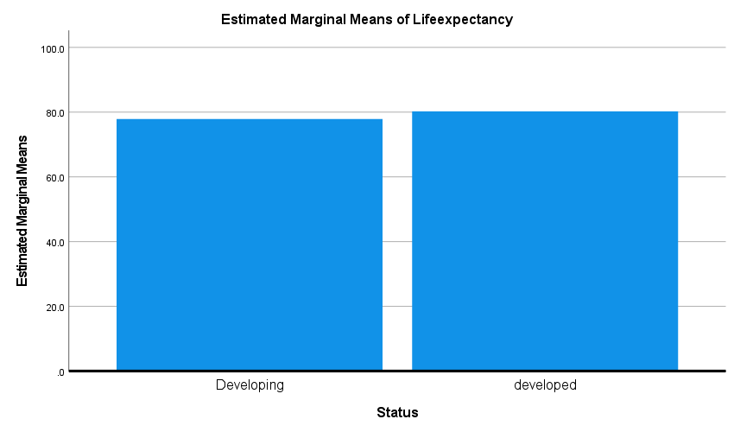

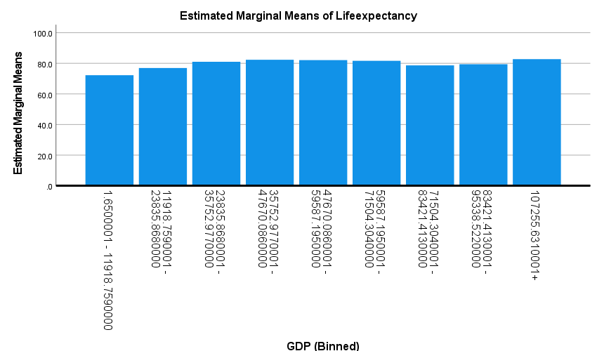

AdultMortality

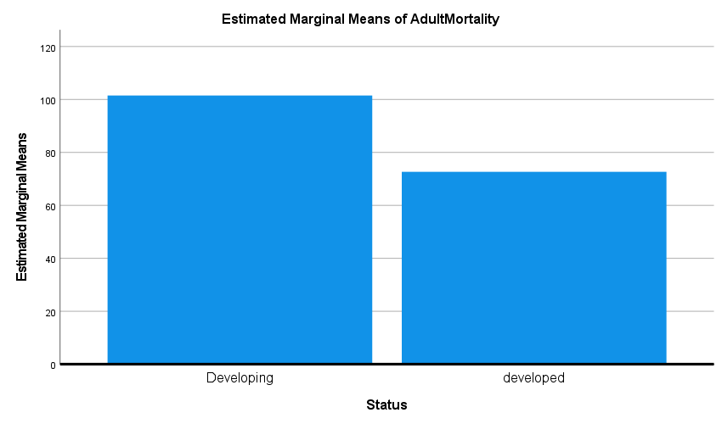

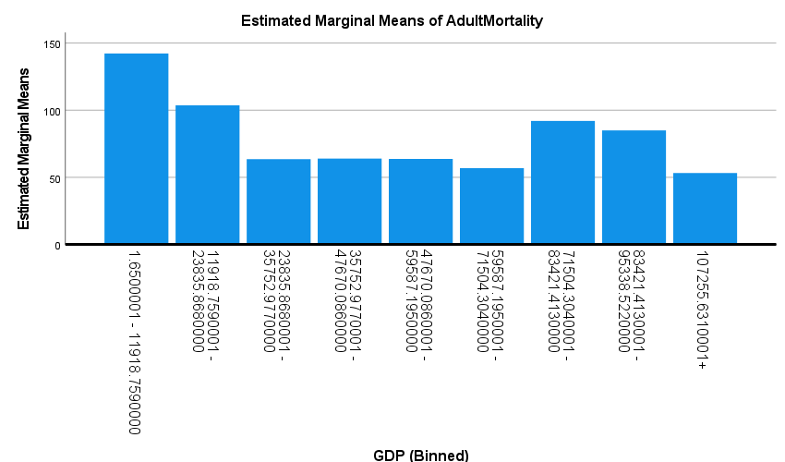

SAVE OUTFILE='D:\QN2\SM_CW-QN2.sav'
/COMPRESSED.

